**CLASS DIAGRAM ABSTRACT DAN INTERFCE PADA SISTEM INFORMASI TATA TERTIB YANG DI IMPLEMENTASIKAN DENGAN METHOD OOP**



**Oleh :**

**Ahmad Yazid Ilham Z (2341760156)**

**Amilil (2341760170)**

**Sabrina Rahmadini (2341760155)**

**Safrizal Rahman (2341760151)**

**Shabrina Qottrunnada (2341760160)**

**JURUSAN TEKNOLOGI INFORMASI**

**POLITEKNIK NEGERI MALANG**

**2024/2025**

GAMBARAN BLUEPRINT/KASAR

CONTOH INTERFACE CLASS DIAGRAM

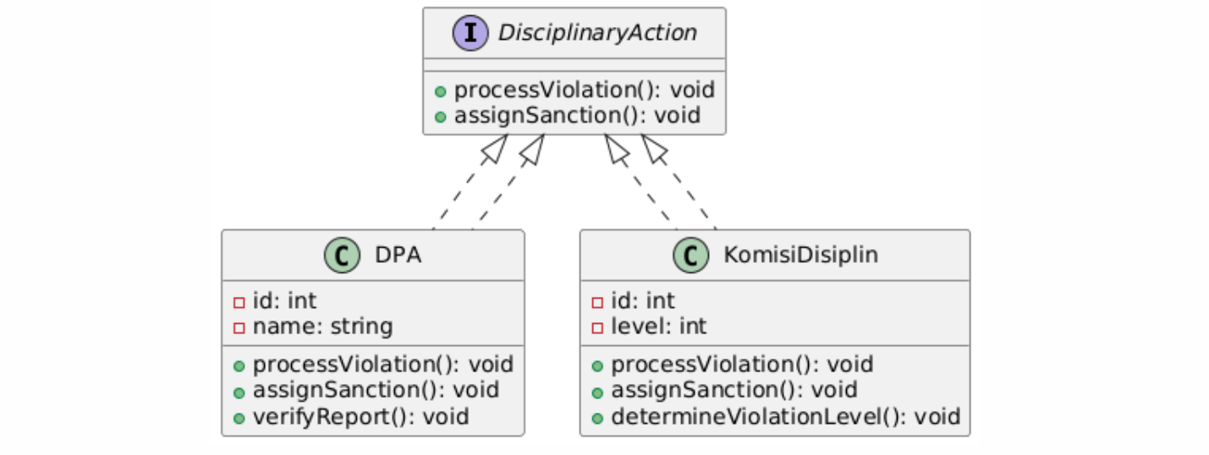

ABSTRACT CLASS DIAGRAM

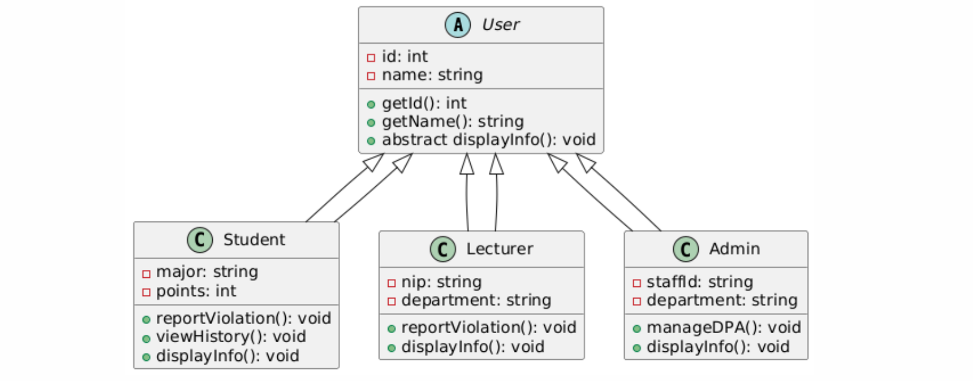

SISTEM INFORMASI TATA TERTIB

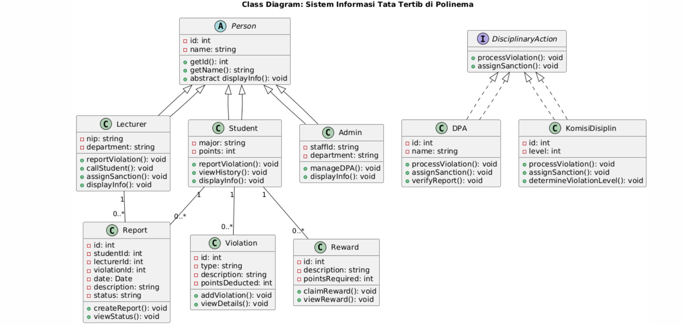

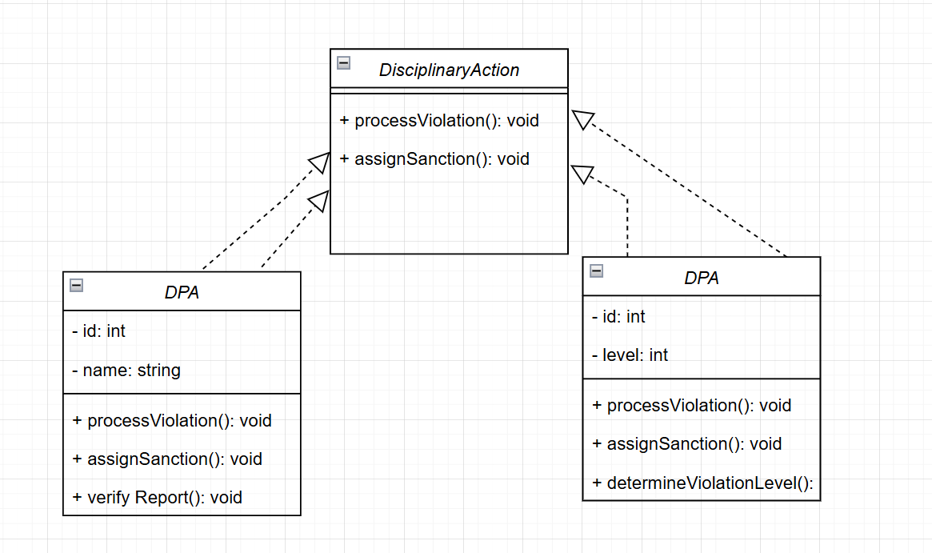

IDENTIFIKASI

**Interface: DisciplinaryAction**

* Methods: processViolation(), assignSanction()

**Class: DPA (Disciplinary Committee)**

* Attributes: id, name
* Methods: processViolation(), assignSanction(), verifyReport()

**Class: KomisiDisiplin (Disciplinary Commission)**

* Attributes: id, level
* Methods: processViolation(), assignSanction(), determineViolationLevel()

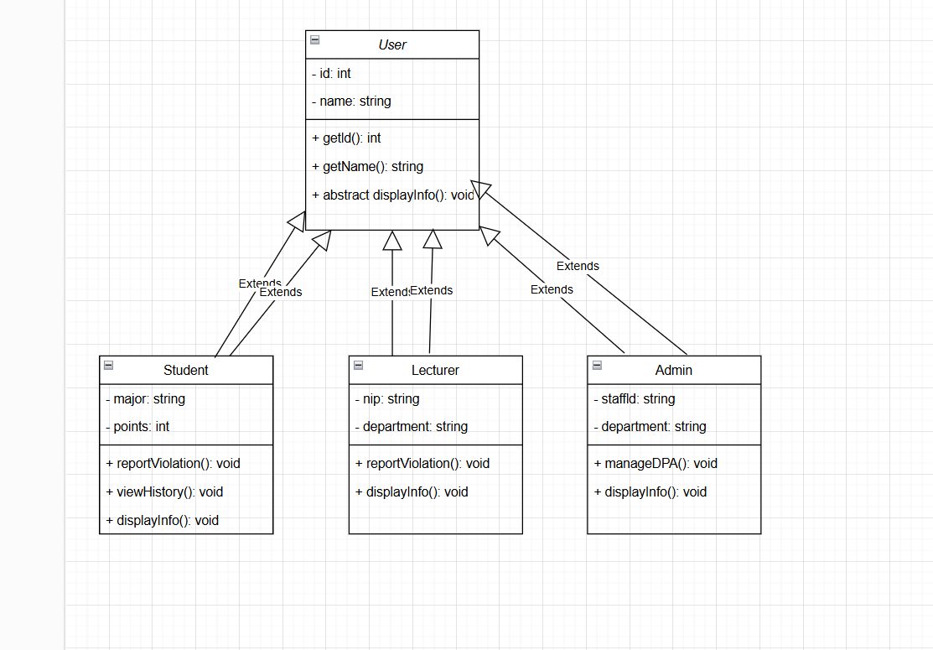

**Abstract Class: User**

* Attributes: id, name
* Methods: getId(), getName(), displayInfo()

**Class: Student**

* Attributes: major, points
* Methods: reportViolation(), viewHistory(), displayInfo()

**Class: Lecturer**

* Attributes: nip, department
* Methods: reportViolation(), displayInfo()

**Class: Admin**

* Attributes: staffId, department
* Methods: manageDPA(), displayInfo()